Password: CSI309@vnit End Semester Examination Winter 2020
Branch: 5th Sem, B.Tech. CSE Course: Operating Systems (CSL309)
Duration: 1.5 hour Max. Marks: 30
Note: Answer the questions strictly as per the answer script template already provided. State clearly any assumptions and reasoning for the answers, wherever necessary.

Q1. Study the following program segment and a) explain the output of the program (assume inclusion of necessary header files so that the code compiles and executes successfully) and mention a use-case of this type of code segment b) Draw figures that shows the status of file descriptor array of the processes involved, the global open file table, in-memory inode and the pointers linking these data structures just after the execution of fork()statement. Mention the content of any relevant information of these data structures in the figures. c) What changes should be reflected in the figures after execution of the close(in) statement by the processes involved. [1.5+2+1= 4.5 marks]

int main(int argc, char *argv[]) {
int in, pid, stat;
char *args[] = {"grep", "xyz", NULL};
in = open("file", O_RDONLY);
pid=fork();
if(pid==0){
dup2(in, 0);
close(in);
execvp("grep", args);
}
close(in);
waitpid(pid,&stat,0);
printf(" The end\n");
return 0;
}
Ans:
a) It is basically a segment of a shell process which is creating a child process and executing the given command: grep xyz file by redirecting the standard in to a file for the grep command to take input and search the occurrences of xyz in the file and output on standard out (here the default monitor screen). The parent process (like a shell usually does) waits for the child process to complete and then prints the message before exiting (as here) or becoming ready for the next command.

b) after fork()
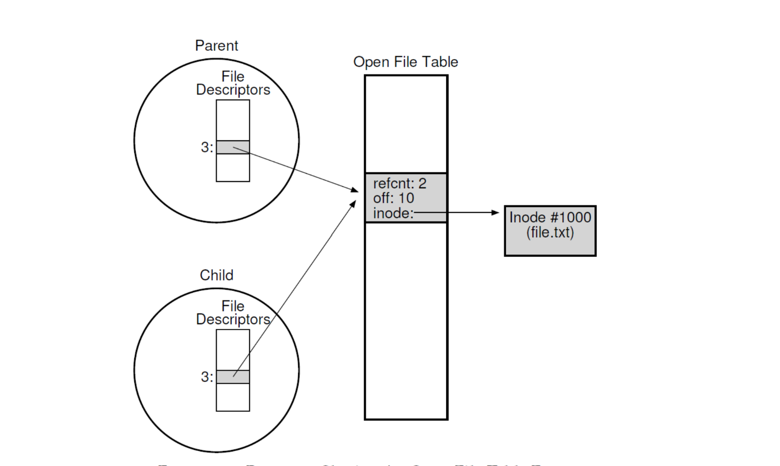

b) after close() the changes will be – In both the parent and child file descriptor table/array the pointer in Fd[3] will become null (0.5 marks) and in child table, the Fd[0] (STDIN) pointer will now point to that file entry in the system wide file table (0.5 marks).

Q2 a) Consider a primitive disk that has 50 tracks. A seek takes 5 ms (on average) to move the arm head per track. On an average, without optimization (to try to put sequential file data in blocks with close proximity) two logically consecutive blocks in a file will be about 10 tracks apart. however, with an optimization attempt to cluster related blocks, the mean inter-block distance can be reduced to 2 tracks. If the rotational latency is 50 ms and the transfer time is 15 ms per block, how long does it take to read a 50-block file in both cases. [3 marks]
Ans: It takes 15 msec to transfer one block, thus transferring 50 blocks takes 750 msec. If the average number of tracks to move is 10, then at 5 msec per track this will take 2500 (5x10x50) msec for a 50 block file. Lastly, the rotational latency is 50 msec and is added for every block, thus total is 2500 msec rotational delay. Thus the non-optimized solution for this problem is 750 + 2,500 + 2500 = 5750 msec to transfer a 50 block file.
Optimization only alters the mean interblock distance to 2 tracks and thus reduces seek time from 2500 to 500 (5x2x50) msec. Thus the total time for an optimized disk is (750 + 500 +2,500 =) 3750 msec.

b) What is the maximum file size supported by a file system with 16 direct blocks and a single, double, and triple indirection? The block size is 512 bytes. Disk block pointers/numbers can be stored in 4 bytes. You can leave the answer in exponential terms. [2.5 marks]
Ans: block size = 512
number of block pointers in an indirection block
= block size / 4
= 128
number of blocks for file data in that file object
= 16 + 128 + 128^2 + 128^3
Maximum file size:
(direct + single indirect + double indirect + triple indirect) * (blocksize)
= (16 + 512/4 + (512/4)^2 + (512/4)^3) * (512)
= 1,082,204,160 bytes ~ 1GB

Q3. Consider the following synchronization problem: There are three process P, Q, and R. All of them are executing a loop from 1 to N. You wish to enforce the condition that no process may start the execution of (I+1)^{th} iteration until the other two processes have completed the Ith iteration. Using a pseudo code, show how this condition can be correctly enforced (of course without causing deadlock) using three semaphores (Don’t use any lock or condition variable). [4 marks]
Ans:
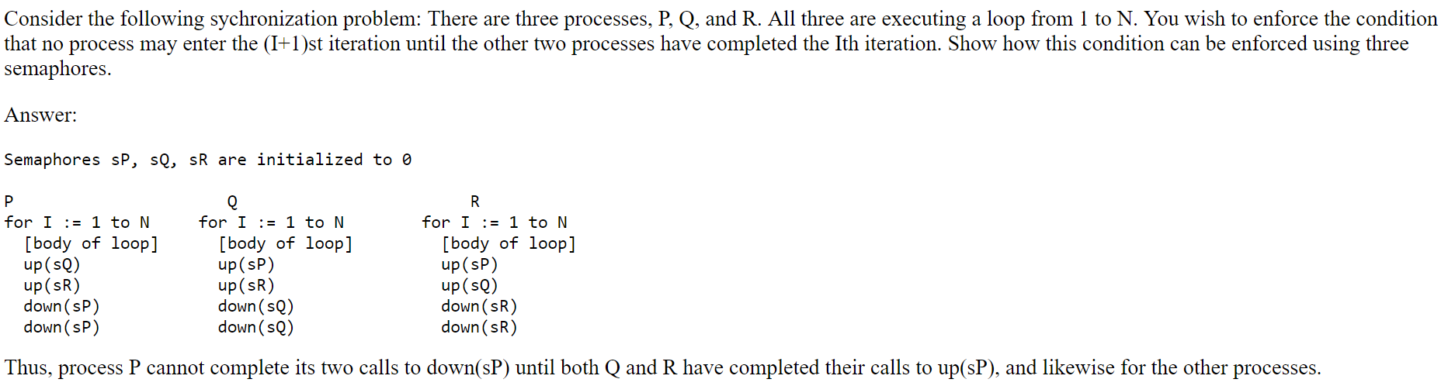
Note: up() is basically sem_post operation and down() is sem_wait() operation

Q4. (a) For each of the following pseudo code segments, where the variables are initialized as shown and thread A and B can run concurrently, what are the possible ending values of x when both threads A and B try to run to completion. Support your answers with brief explanation/reason. [4 marks]
(b) Does any of the code segments guarantee a unique value of x with the completion of both threads? If not, what minimum change is required in any code segment to guarantee that. [1 marks]

(i) | (ii) | (iii)
Int x=0;  Int y=23;  Thread A  {  x=x+1;  }  Thread B  {  x=y+1;  } | Int x=0;  Int y=23;  Mutex m ;  Thread A  {  lock(&m);  x=x+1;  unlock(&m);  }  Thread B  {  lock(&m);  x=y+1;  unlock(&m);  } | Int x=0;  Int y=23;  Mutex m ;  Condition Variable s;  Thread A  {  lock(&m);  wait(s, &m);  x=x+1;  unlock(&m);  }  Thread B  {  lock(&m);  x=y+1;  signal(s);  unlock(&m);  }
Possible ending values of x | Possible ending values of x | Possible ending values of x

Ans: a)
- Possible ending values of x : _______1, 24, 25_______________
- Possible ending values of x : ________24, 25______________
- Possible ending values of x : ______25, but also the possibility of thread A sleeping forever and in that case if x value is printed out it will come to be 24______

b) In code segment iii) if we add a state variable done and check it before calling wait in thread A and set it in thread B before calling signal (just like we do in parent child join problem) then we guarantee the unique value of x to be 25.

Q5 a) Briefly explain with a practical example scenario, how deadlock can occur within an operating system code. [1.5 marks]
Ans: In large code bases like OS, complex dependencies arise between components. For example, The virtual memory system might need to access the file system in order to page in a block from disk; the file system might subsequently require a page of memory to read the block into and thus contact the virtual memory system. In this way, circular dependencies may occur naturally in the code.

b) Assume a system where all resources are singletons (i.e. there is a finite set of resource types and there is only a single instance of each resource type) and for each process, the hardware can record its timestamp - the time of day at the instant that the process first starts executing. Assume the system clock has sufficiently high resolution so that no two processes are given the same timestamp and system has the ability to deallocate/preempt/abort/restart any process. Propose a method for preventing deadlock (clearly explaining which of the necessary deadlock causing condition it prevents) between processes (while avoiding starvation situation for any process) in the system using this information only. [2.5 marks]
Ans: We can use the following rules: 1) If a process Pi having timestamp ti requests a resource currently held by some other process Pj having timestamp tj then:
Pj is forced to release it’s resource and Pj is aborted if and only if tj > ti holds (i.e the younger process is aborted)
2) The process which has been aborted is immediately restarted from its beginning, but having the same timestamp as it previously had been assigned

This scheme prevents the necessary condition of “hold and wait” for the deadlock (and indirectly the circular wait condition also) as one of the process involved in the contention will have to release its resources. In this scheme of having older processes cause newer ones to be aborted when there is contention for a resource, the processes get access to resource in (roughly) timestamp-order and thus every process will eventually get to run and complete (without getting starved). If the rule was reverse (i.e younger causing older to abort) then there would have been starvation.

Q6 a) Explain any 3 distinct advantages in the design of the Unix file system API where the file needs to be first opened and then accessed (for subsequent read/write operations) using the file descriptor (instead of accessing it using file path or file’s inode number) [3 marks]
- Expensive tree traversal for the file path is done only once during open operation (avoiding for subsequent access)
- A valid FD is returned only after all permissions checks related to the file is satisfied. This gets done during open.
- If multiple process open the file, then it is easier to track different offsets using the FD

b) What are the problems with shortest seek time first (SSTF) method of disk scheduling and how they are addressed in an alternative strategy. Does any of the Disk scheduling strategies discussed in the course, guarantees to be always optimal (Justify your answer)? [4 marks]

Ans: Problems with shortest seek time first (SSTF) method of disk scheduling are:
1. Ignores/does not accounts for rotational delay/time : Shortest access/positioning time first (SATF or SPTF) is the alternative strategy which takes into account both the seek and rotation time. The implementation however depends on whether rotation is faster than seek or vice-versa or roughly equivalent.
2. starvation: If there a steady stream of requests to the tracks near to the current head position then requests to any other tracks will starve. The solution is to use some kind of scanning strategy while freezing the queue to be serviced during one sweep. Ex. Elevator/SCAN, C-SCAN, F-SCAN/bounded window BSATF – brief explanation of anyone.

None of these strategies are guaranteed to be optimal because even the SPTF/SATF just makes greedy choice which may not necessarily give the optimal path/schedule. That would require enumerating all possible paths cost (kind of dynamic programming) which is very difficult to compute in realtime inside disk drive.

(NOTE: you can naturally use the extra page in the template, if your answers exceeds the one page space reserved for each question (including the subparts). Don’t forget to scan both the extra page even if you don’t write anything there).
----------------- xxx -------------------

